THE PERILS OF W-SITTING
- What is W-sitting:
W sitting: hips in extreme internal rotation with buttocks planted between the legs.
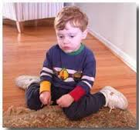

- Why do some children W sit
- Makes it “easier” to sit. W sitting gives false trunk control and hip stability, making it easier to sit and play.
- Child can play with toys in the front, but, when w-sitting children cannot laterally weight shift or twist to play with toys on the side.
- W sitting prevents skills necessary to develop good core control, fine motor skills and hand dominance
- Trunk (core)control: W sitting mechanically stabilizes the child in a straight aligned position hence core gets weak and balance reactions are not needed.
- Rotation: rotation (twisting) cannot occur when in W-sitting hence abdominal muscles that control rotation are not strengthened (obliques).
- Midline crossing (reaching across the body): lateral shifting and rotation cannot occur when W-sitting
- W sitting causes Separation of the 2 sides of the body which then delays more advanced skills.
- Cross body (bilateral) movements are necessary for brain development
- L/R integration is necessary for other milestones such as reading and writing
- Lack of hand dominance: due to the lack of trunk rotation incurred when w-sitting, children are less inclined to reach across their body to pick up an object: instead they pick up things on the R with the R hand and things on the L with the L hand.
- orthopaedic concerns of W sitting
- W sitting can predispose a child to hip dislocation
- Hip sockets become shallow from lack of proper contact
- W sitting causes tightness in the hamstrings, hip adductors, external rotators, and heel cords. Tightness in these muscles can cause problems in teen years as well as adulthood.
- W sitting causes a child to be more prone to a toe in gait
- W sitting places an extreme lateral stress on the knee joints which can follow into adulthood.
This can translate into walking with knock knees in adulthood.
- W sitting predisposes the child to back problems as an adult due to
- Weak core
- Tightness in hamstrings adductors, heel cords
- Improper hip alignment
- How to prevent
- Prevent w-sitting from becoming a bad habit.
- Remind child to “fix their legs”
- Alternative positions
- Criss cross applesauce or pretzel sitting (tailor sitting)
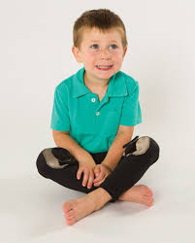
- Long sitting with legs out straight in front
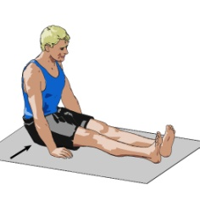

- Side sitting: This is when your childs’ knees are bent and their feet are both going toward the same side of their body. In this position they can still use their trunk muscles. Make sure they are switching between having their feet to the left and their feet to the right side from time to time.
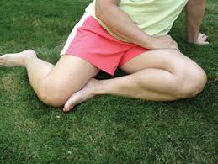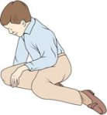

- Kneeling: Their feet will be underneath their bottom, not on either side of their hips!

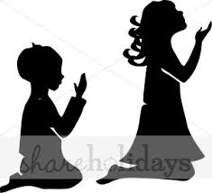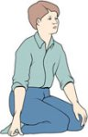

- Ring sitting: This position is similar to criss cross applesauce position, except that your child’s legs are not crossed in front of them. Instead their legs form a ring with their feet touching to complete the circle. This position is more stable position than criss cross applesauce when children are first learning to sit.
